Hotel

Management

System

2020.6.18

Jinan Foreign Language School

International Center

Year 11 AP

Elective A

Group 1

1. Development environment and tools

2. Description of the project or function-requirements document

3. Compilation purpose (user characteristics and level)

5. Modules and relationships

6. Class or term description

8. Project progress estimate

9. Difficulties in estimation (conditions and restrictions)

10. User Interface and Interaction

11. Problems and Fix Instructions-Bug Fix Document

12. Performance Analysis and Optimization

1. Development environment and tool

-Undecided

-Java 8+

-IDEAJ

II. Description of the project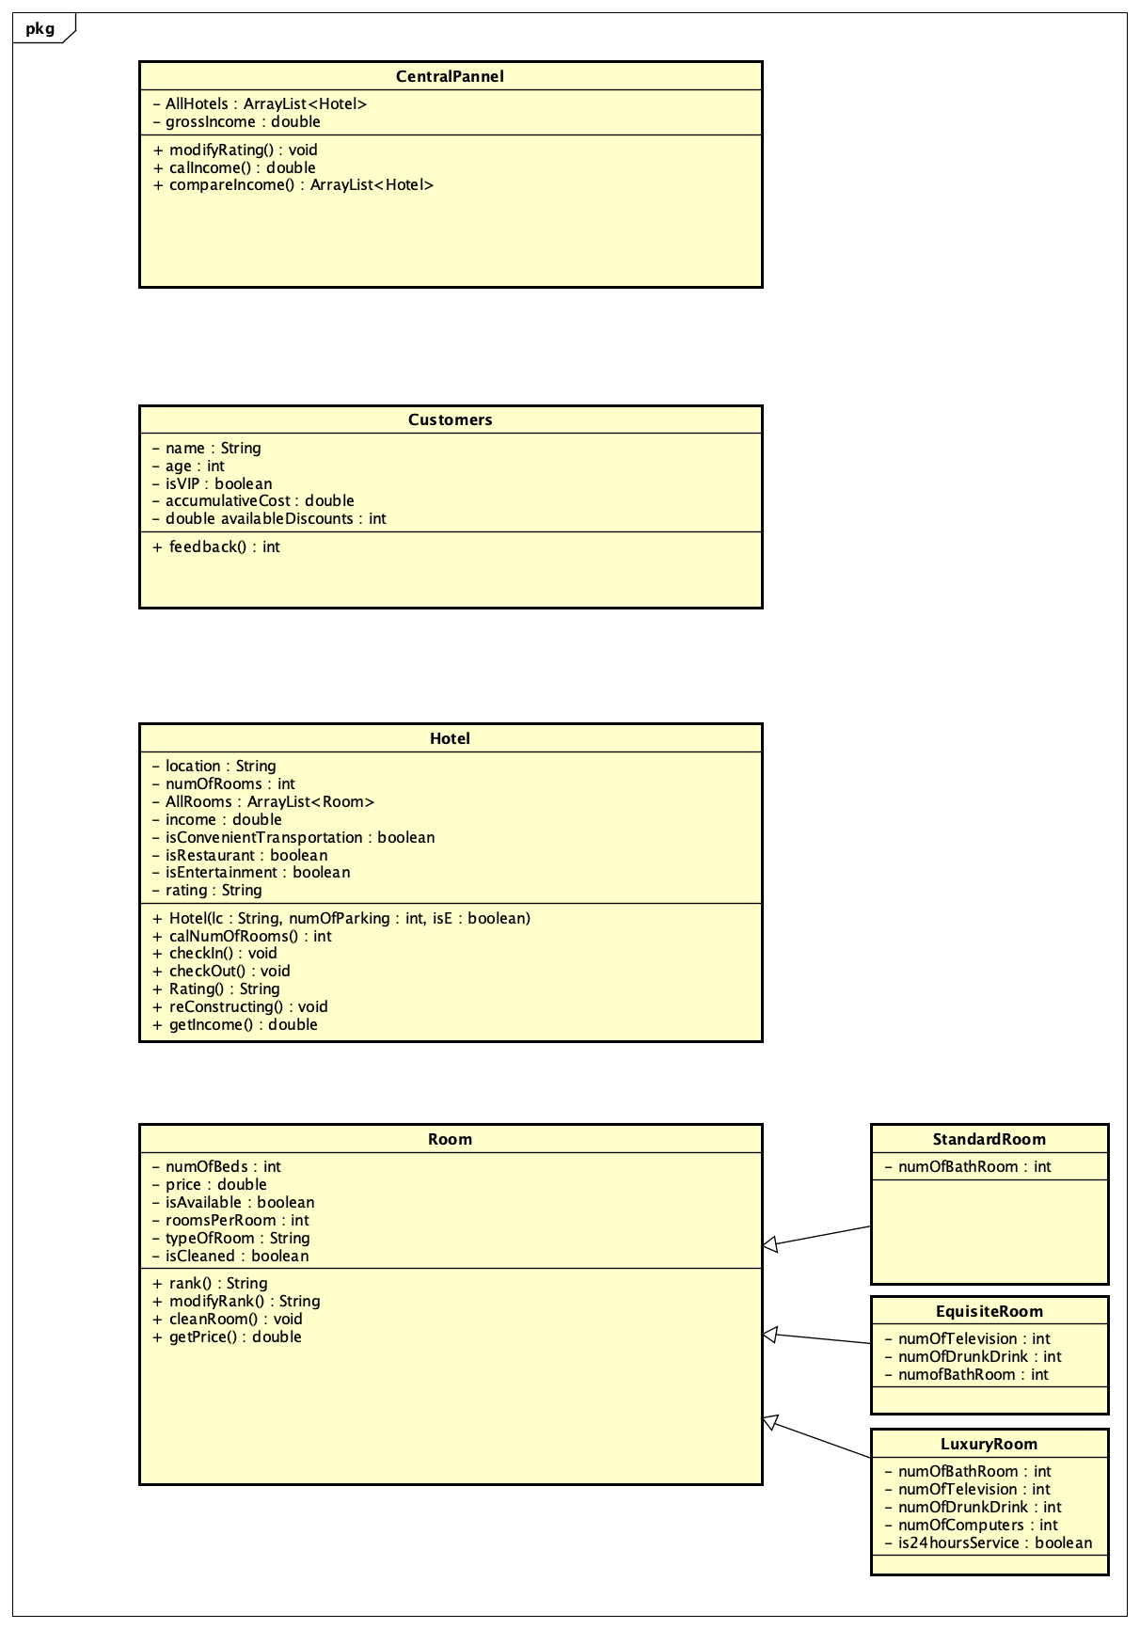

III . Compilation purpose

We are designing a system that can from the top to the bottom manage the finance, construction, and activity for A Global Hotel Company. The target users will be the common staffs who know the basic computer operation.

This software can efficiently expedite and bolster the connection of hotels of company, reducing the unnecessary cost or enhancing contact among hotels.

IV. Module and relationship

CentralPannel

->customer{

1. The criteria for isVIP

a. Night >= 30

Cost 2999+, 0.89

29999+, 0. 69

59999+, 0.59

b. Night >=65

5999+ 0.79

59999+ 0.49

100000+ return “Certification”

}

->Hotel

1. Method getInfor{

收益，评价

增长量低—-build more

高— build less

}

2. Change hotel rating

Customer

-> 1. al<Hotel> favoriteHotels

2. Check + feedback

3. method consumption{acct+room.price}

-> room {

Destroy (String )

Save in desk}

HumanResource

Staff->manager

Hotel

-> customer {

Get—-

}

-> room

Get

Room